Holiday Bazaar

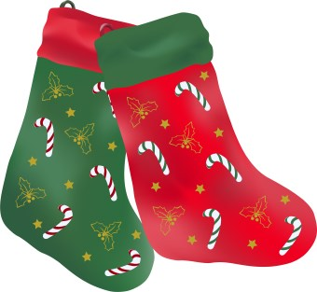
Sat., Nov. 21st, 2026
Libertytown Fire Hall
8:00 am – 2:00 pm
12027 South St. Libertytown, MD 21762

Crafts, Homemade goodies, sandwiches, soups, bake table, raffles and much more…


For more information for table rentals call Mary 301-401-2824

Sponsored by
Libertytown Volunteer Fire Department Auxiliary

